DAVID ARNOLD

daverno@au1.ibm.com

Abstract

Leveraging the ACE micro services 1,2 and 3 on RHOS and testing them with IBM (Rational) Integration Tester. The IBM (Rational) Service Virtualization Tester will also be used for mocking and stubbing ACE MS2 and an MQ backend application

IBM Middleware Tested on RHOS with IBM (Rational) Integration Tester

Testing ICP4i (ACE and MQ) custom images on RHOS 4.2 with Rational Integration Tester

Contents

Using IBM (Rational) Integration Tester with ACE custom images on RHOS 4

Introduction 4

Testing Environment 4

Overview Diagram 5

IBM (Rational) Integration Tester – downloads 5

IBM Integration Tester 5

IBM installation manager for the IBM IT install 6

Import the IBM (Rational) Integration Tester project 6

Navigating the IBM (Rational) Integration Tester 6

Architecture School - Schema library 6

Architecture School - Physical View 7

Architecture School - Logical View 8

Test Factory - Tests 10

Test Factory - Stubs 12

Run the stub 14

Test the stub with a local REST client 14

Explore the MQ Stub 16

Testing ACE Micro Service 2 Stub on IBM (Rational) Integration Tester – local client 17

Run the ACE Micro Service 2 stub 17

Test ACE Micro Service 2 stub with a local REST client 18

Testing ACE Micro Service 2 Stub on IBM (Rational) Integration Tester – Public IP 20

IBM Secure Gateway Service – Server side 20

IBM Secure Gateway Client side 20

Windows firewall 21

Calling RSVT ACE MS2 stub via public IP 22

Calling ACE MS1 via IBM Rational Integration Tester – ACE MS1 calls ACE MS2 stub 22

Start the IBM Rational Integration Tester ACE MS2 Stub 24

Invoke ACE MS1 on RHOS from a REST Client 25

Observe results in ACE MS 2 stub console 26

Invoke ACE MS1 on RHOS from a IBM Rational Integration Tester 26

Observe the results in the stub 27

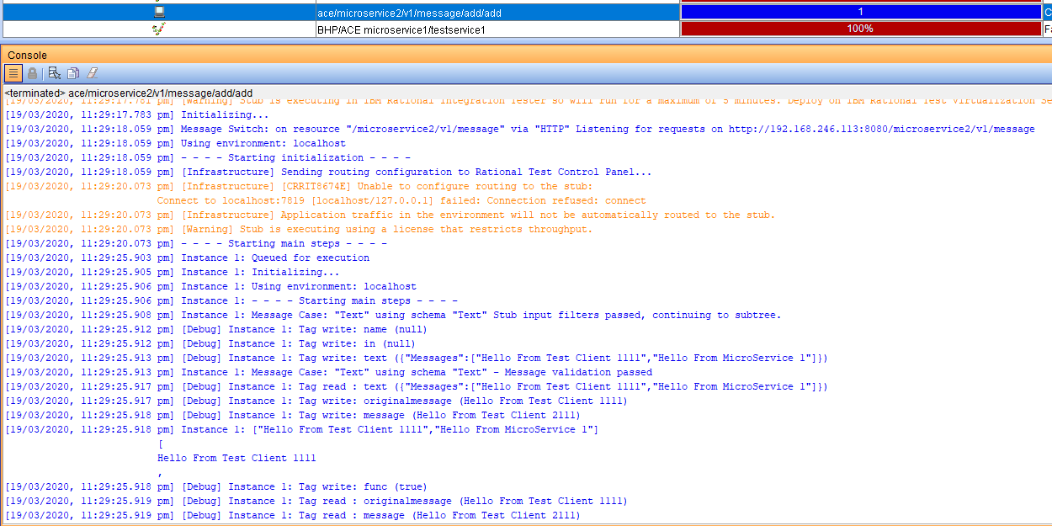 27

Observer the results in the test 27

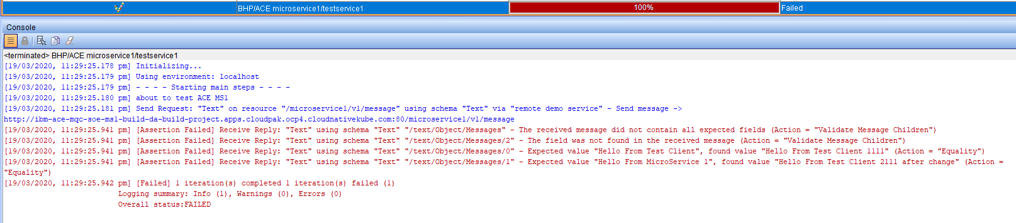 27

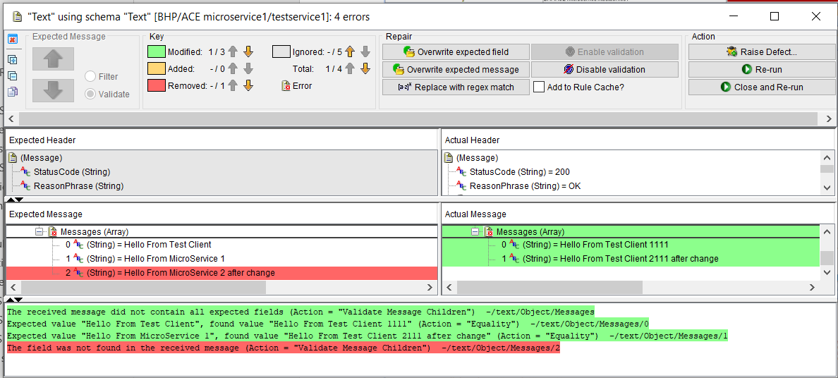 28

IBM MQ Queue Manager as backend for ACE MS3 29

Queue Manager MyAPPQMGR - configuration 29

Channel creation for Linux based queue manager 29

Channel creation for windows based queue manager 29

IBM Secure Gateway Service – IBM Cloud server side 30

Parameters matching ACE MS 3 MQOutput configuration 31

IBM Secure Gateway Service – Client (Laptop end) 32

Windows firewall 32

IBm Secure Gateway Service client side 33

Testing MQ via IBM Public IP – using RFHUTILC 33

Check the result on the target queue manager 35

Testing ACE Microservice 3 to Put to MQ via IBM Public IP 35

RHOS Route for ACE MS3 35

URL for ACE MS3 service 35

Data to test ACE MS3 service 36

Test with REST Client 36

Check Test Results on MQ 37

Using the MQ Stub on IBM Rational Integration Tester as a backend application 37

Review stub parameters in IBM Rational Integration Tester 37

Stub uses IVT.SVRCONN channel definition in the MyAPPQMGR 40

Start IBM Rational Integration Tester Stub to retrieve messages placed on MQ by ACE MS3 41

IBM Rational Integration Tester Stub receives message from ACE MS3 41

# Using IBM (Rational) Integration Tester with ACE custom images on RHOS

## Introduction

Assuming the role of the “disconnected” integration developer we will explore using components of the IBM (Rational) Test Workbench to

1. Test ACE microservices deployed on RHOS 4.2
   1. ACE microservice 1 that will be configured call the “Stub” implementation of ACE microservice 2
   2. ACE microservice 3 that will place a message on MQ for consumption by a “stub”
2. Run “Stubs”
   1. ACE microservice 2 stub
   2. MQ backend application stub

## Testing Environment

In the examples on this document.

* IBM ACE Toolkit is on a Windows T480 laptip
* IBM (Rational) Integration Tester (with Virtualization Test Server) on Windows T480 laptop
* RHOS 4.2 on IBM Public Cloud
* IBM Cloud Secure Gateway Service is used to offer public IP addresses to the T480 laptop
  + Note: CodeReady, Minishift or similar could have be used locally on the laptop
  + The Secure Gateway service would not have been required in that case

## Overview Diagram

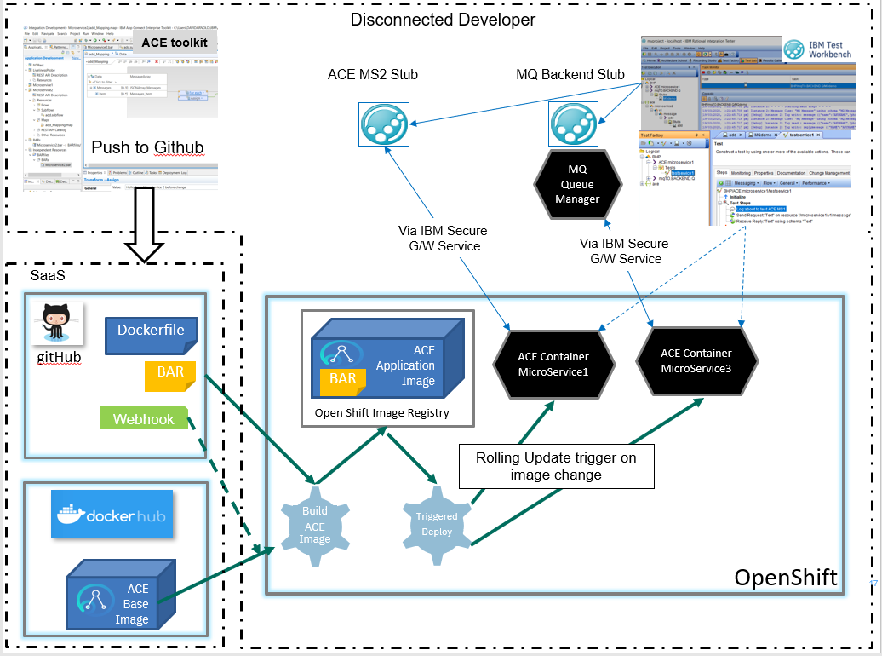

## IBM (Rational) Integration Tester – downloads

### IBM Integration Tester

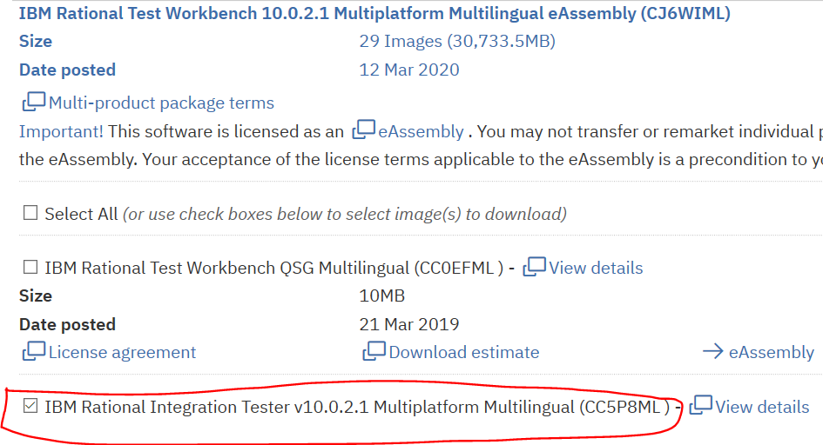

### IBM installation manager for the IBM IT install

https://jazz.net/downloads/ibm-installation-manager/releases/1.9.1.1/agent.installer.win32.win32.x86_64_1.9.1001.20191112_1525.zip

## Import the IBM (Rational) Integration Tester project

Available from github - https://github.com/DAVEXACOM/tekton-ace-example

<https://github.com/DAVEXACOM/tekton-ace-example/tree/master/IBMIntegrationTesterProject>

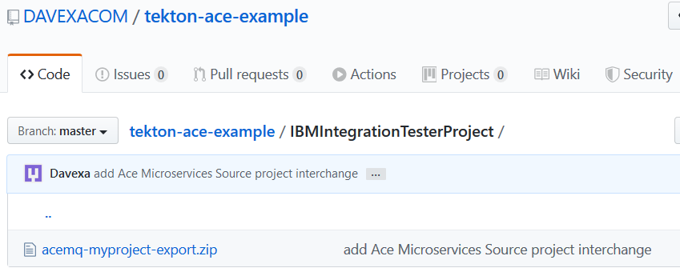

## Navigating the IBM (Rational) Integration Tester

### Architecture School - Schema library

ACE Microservice open api documents imported here

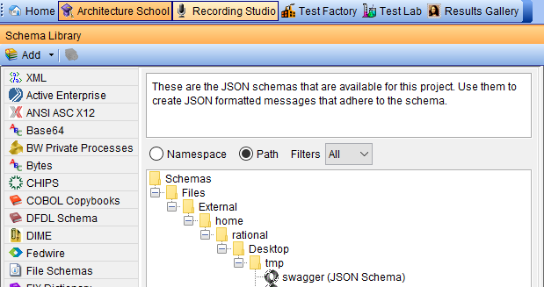

### Architecture School - Physical View

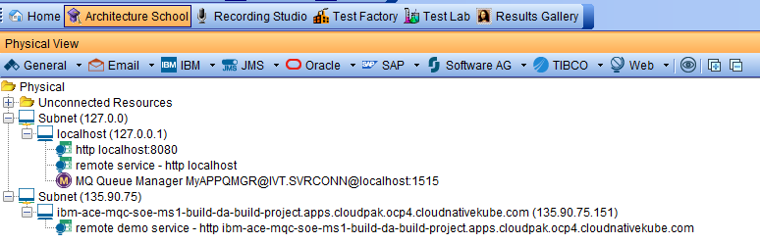

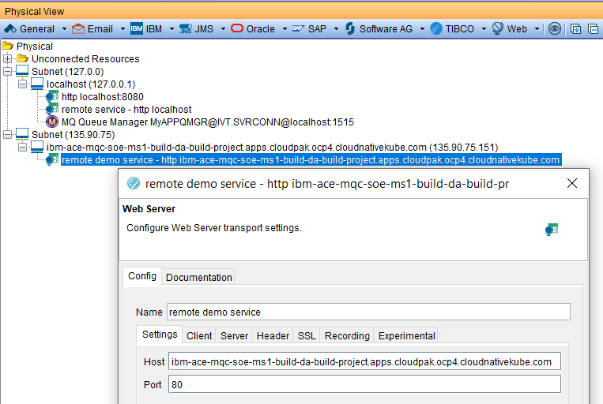

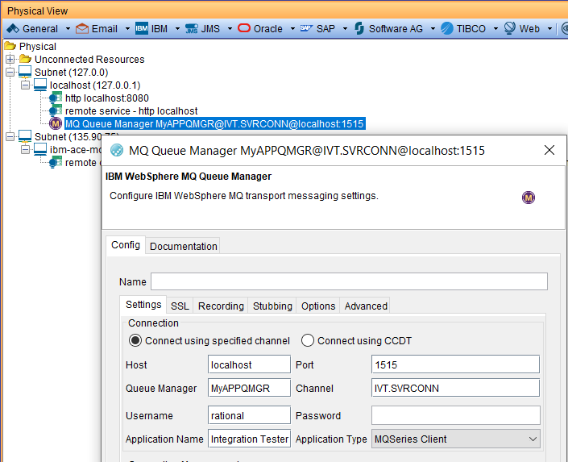

### Architecture School - Logical View

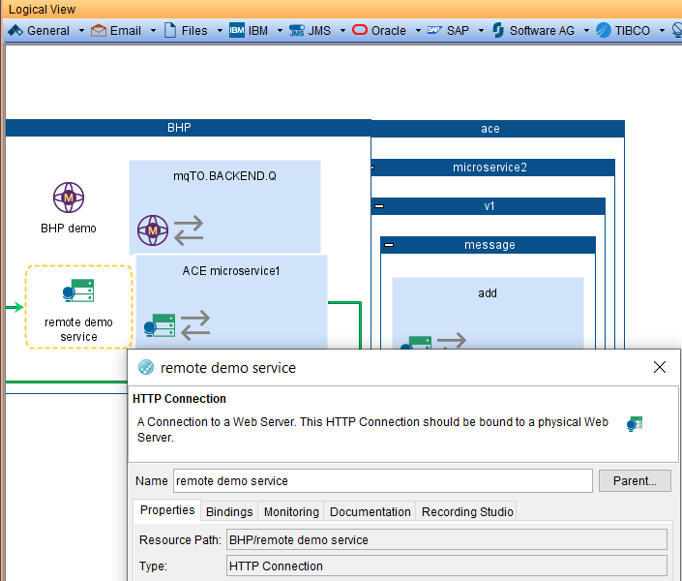

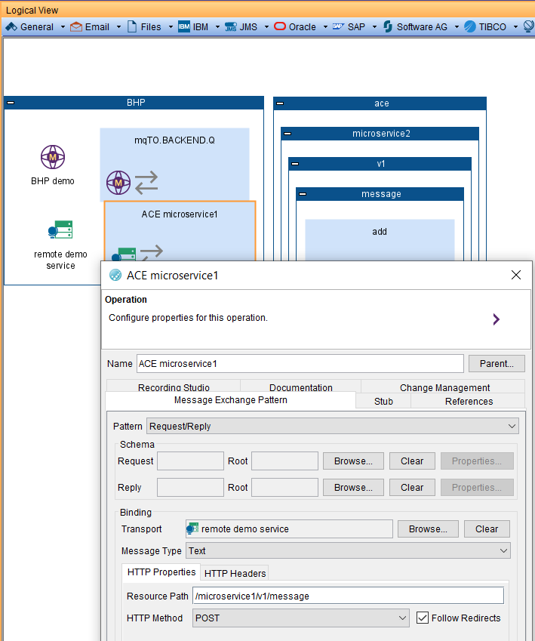

### Test Factory - Tests

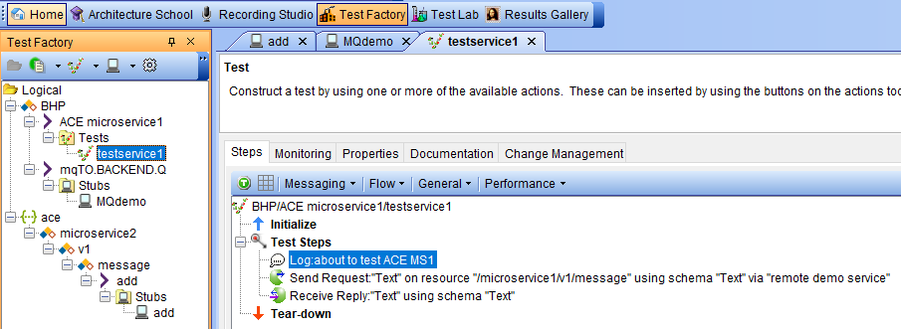

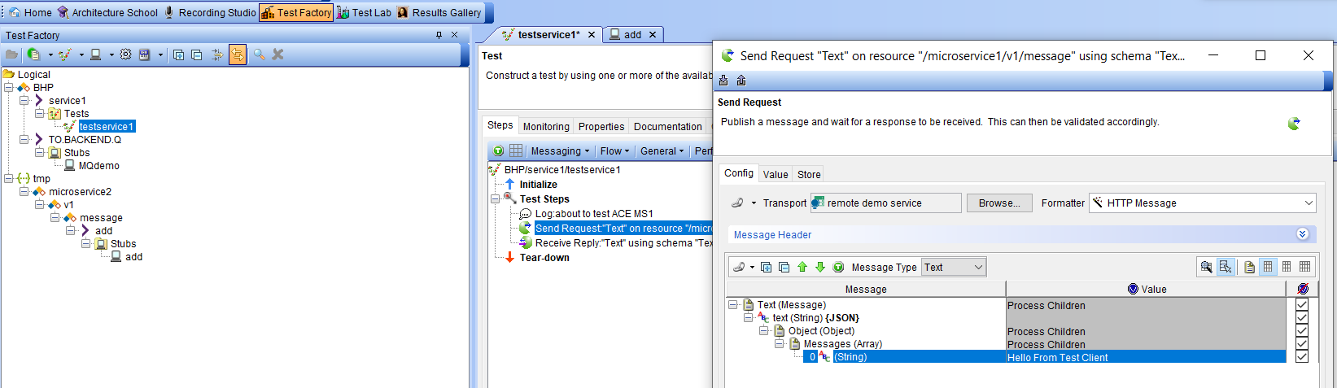

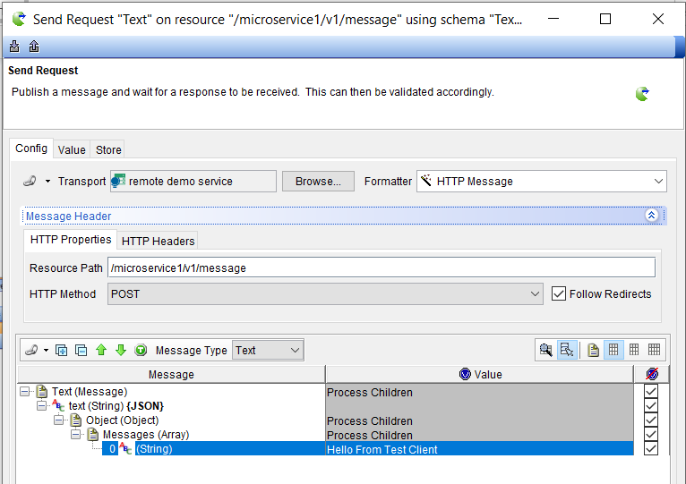

Defines the expected result – for comparison purposes

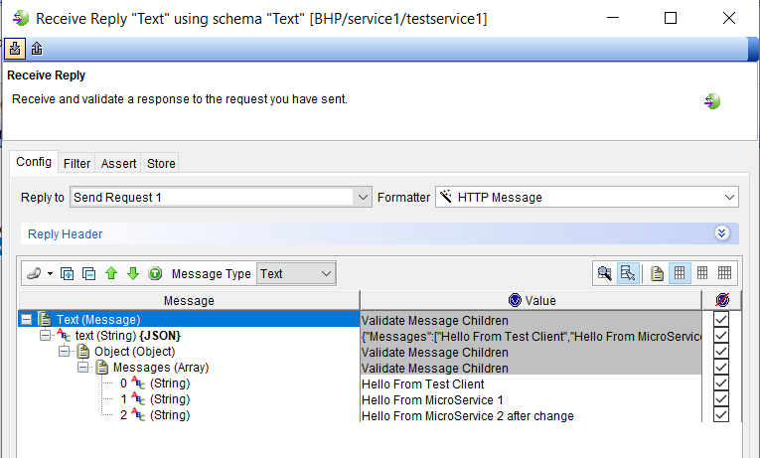

### Test Factory - Stubs

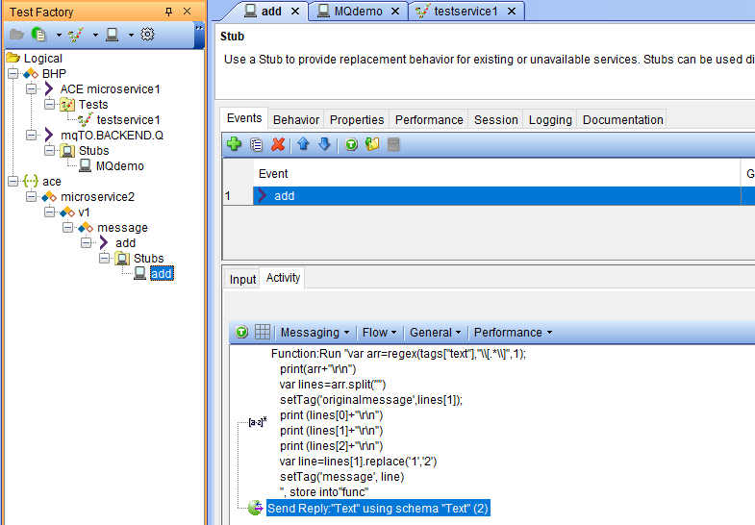

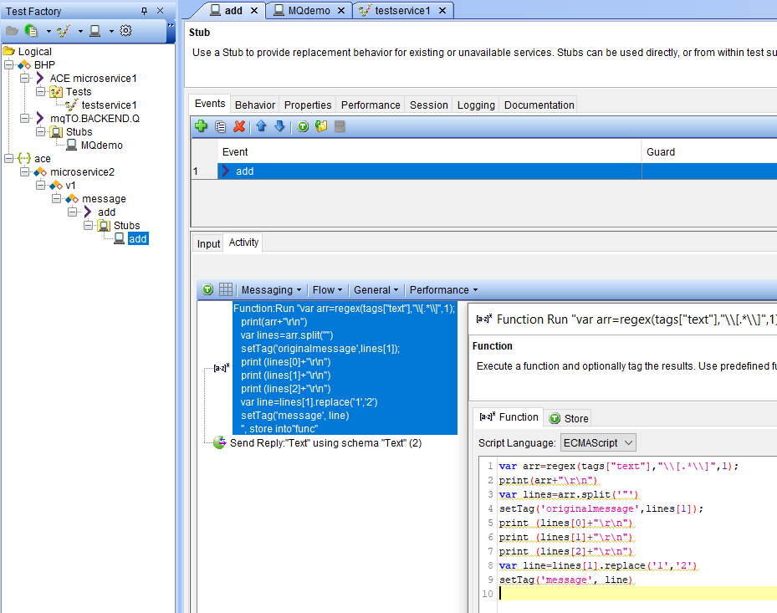

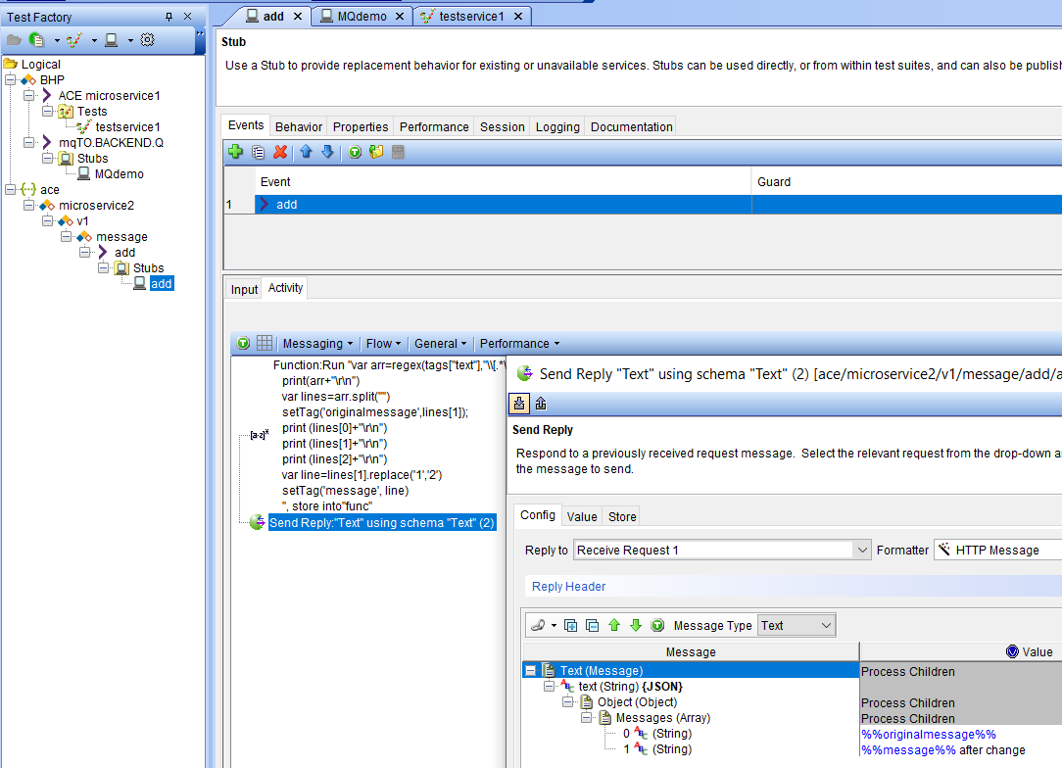

### Run the stub

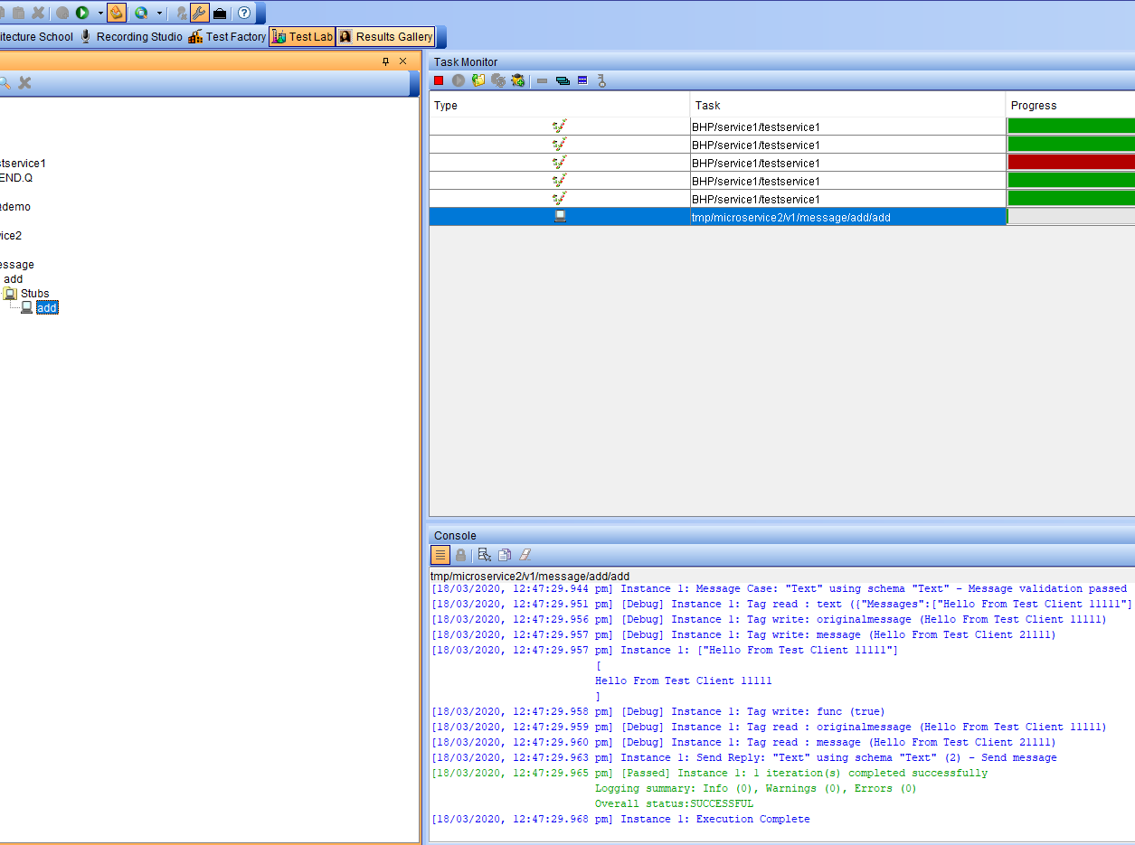

### Test the stub with a local REST client

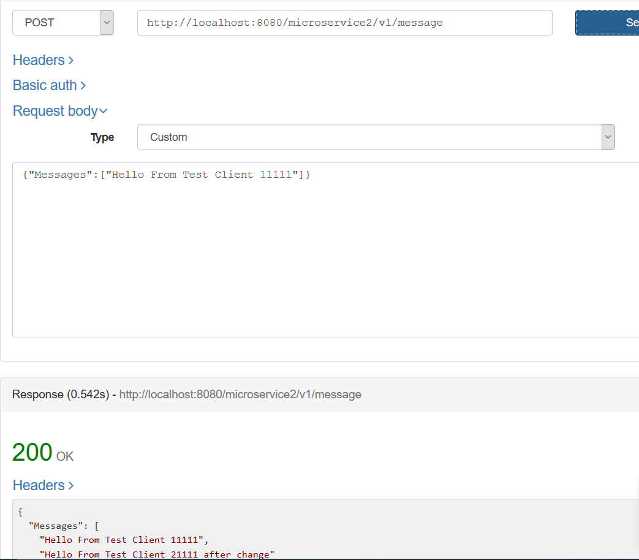

Check the results

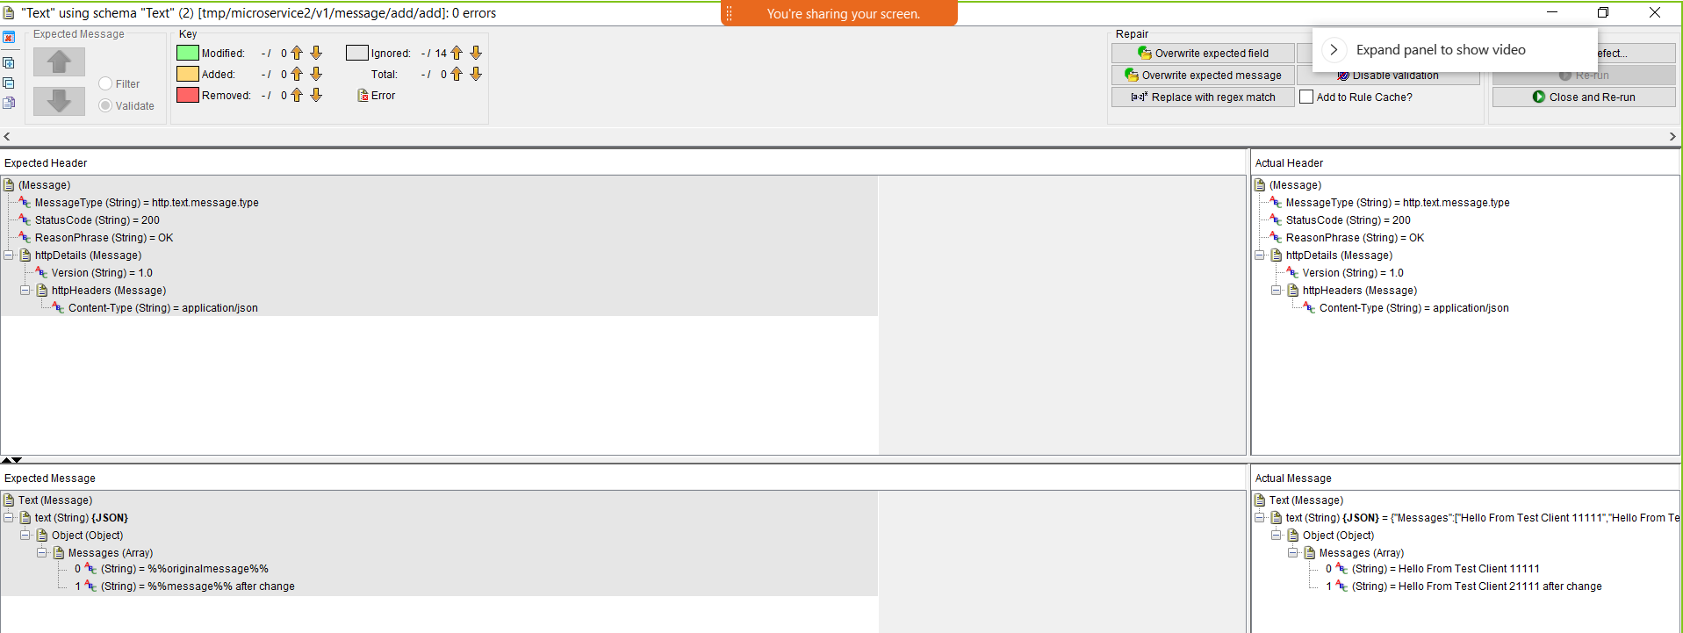

## Explore the MQ Stub

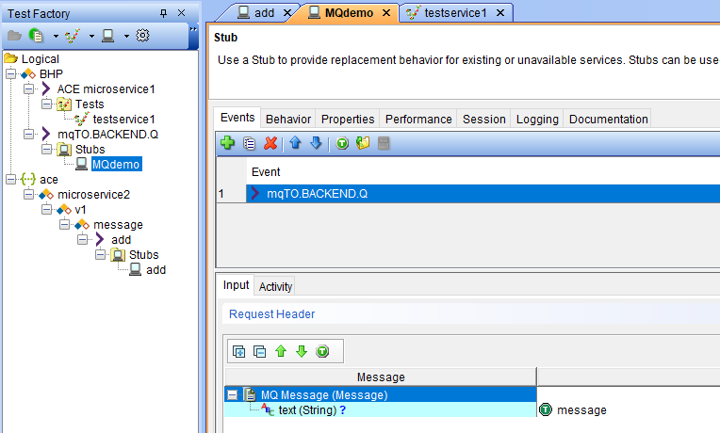

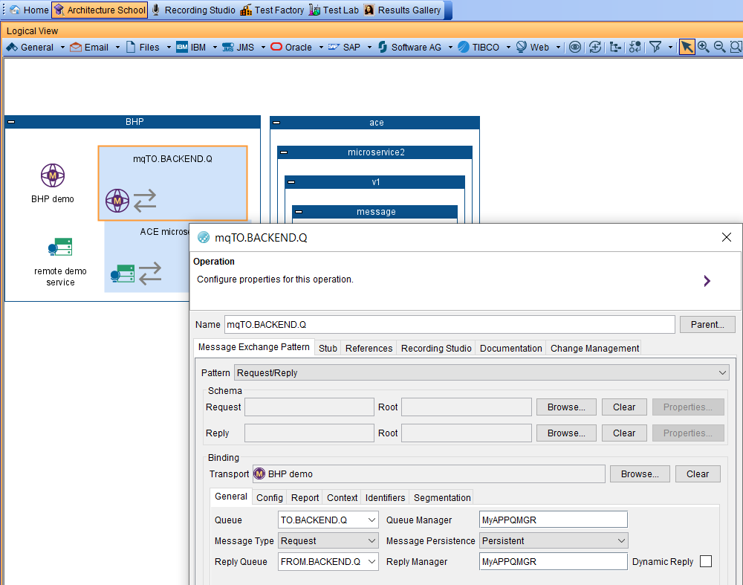

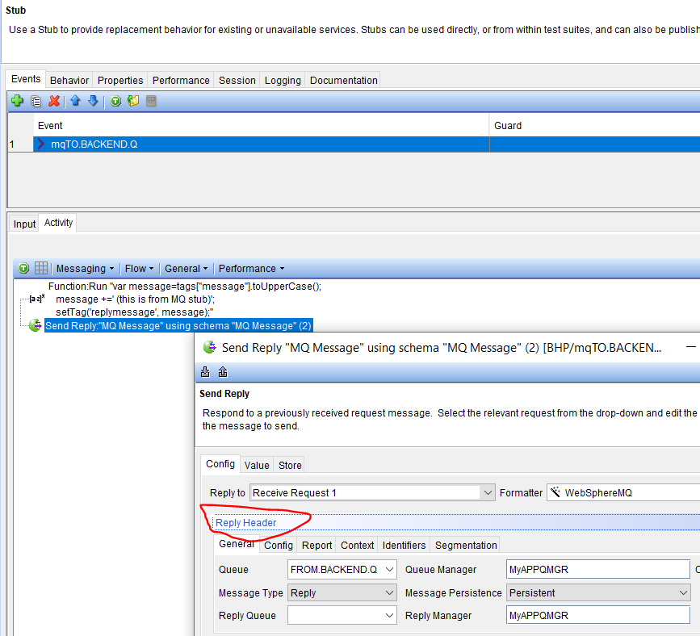

## Testing ACE Micro Service 2 Stub on IBM (Rational) Integration Tester – local client

### Run the ACE Micro Service 2 stub

The stub will stay active for 5 minutes

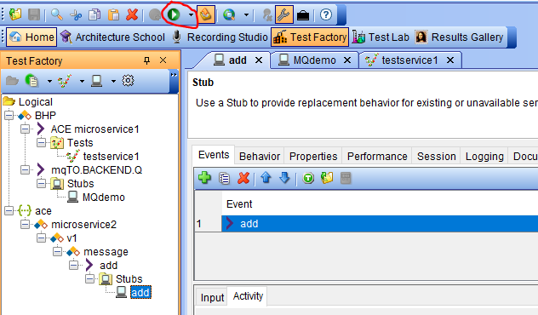

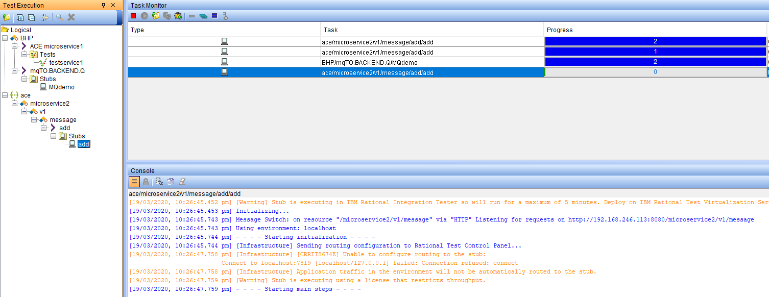

### Test ACE Micro Service 2 stub with a local REST client

POST

http://localhost:8080/microservice2/v1/message

with data

{"Messages":["Hello From Test Client 1111"]}

should return

{

"Messages": [

"Hello From Test Client 1111",

"Hello From Test Client 2111 after change"

]

}

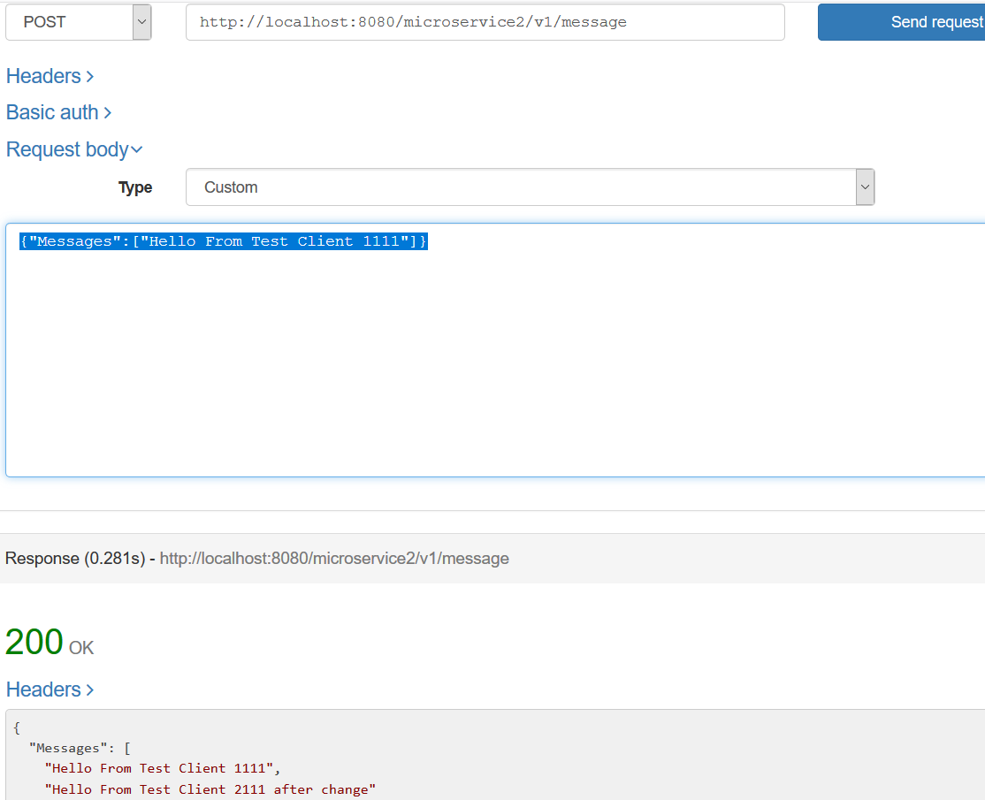

## Testing ACE Micro Service 2 Stub on IBM (Rational) Integration Tester – Public IP

### IBM Secure Gateway Service – Server side

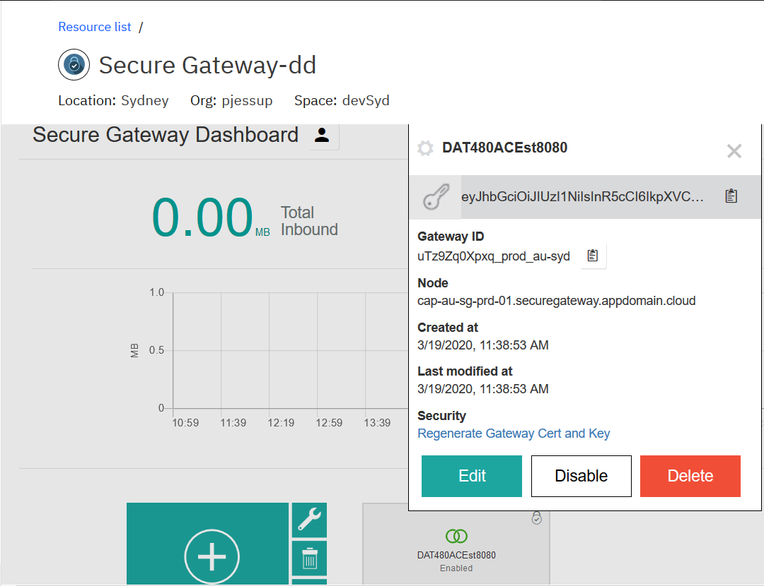

### IBM Secure Gateway Client side

You need the IP address that your machine is using at the time could be wifi adapter, Bluetooth or IBM 9. Address – depends + plus the port. In this example my queue manager is listening on 1515 and my RIT RSVT stub for ACE MS2 is listening on 8080

192…. Is my wifi adapter when at gome.

172 … I my Bluetooth when connected on the phone

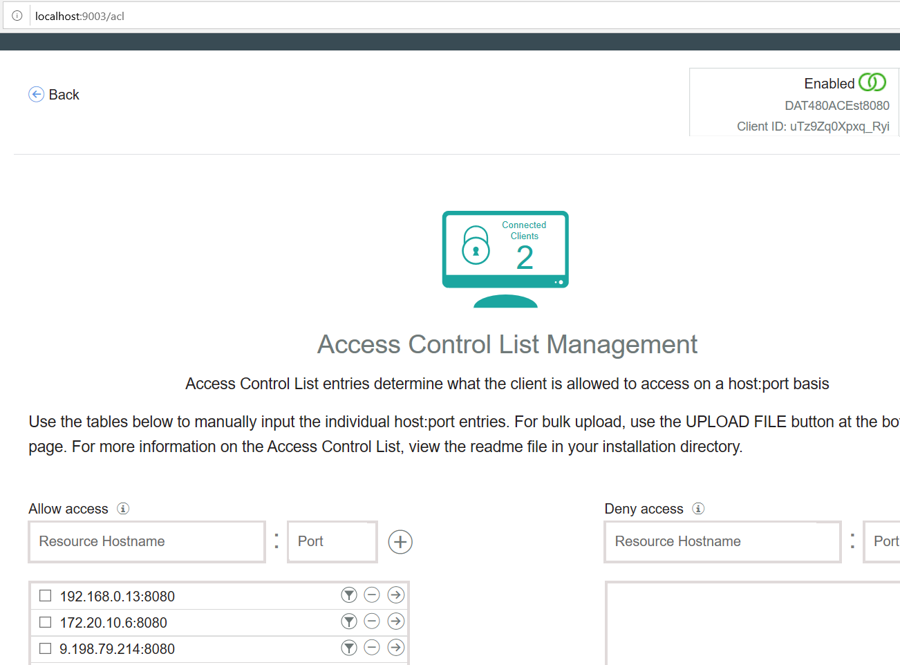

### Windows firewall

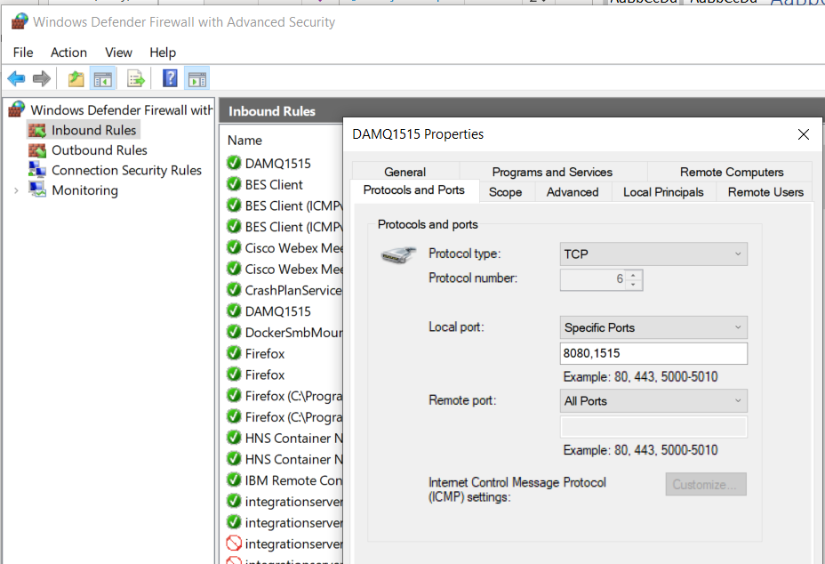

### Calling RSVT ACE MS2 stub via public IP

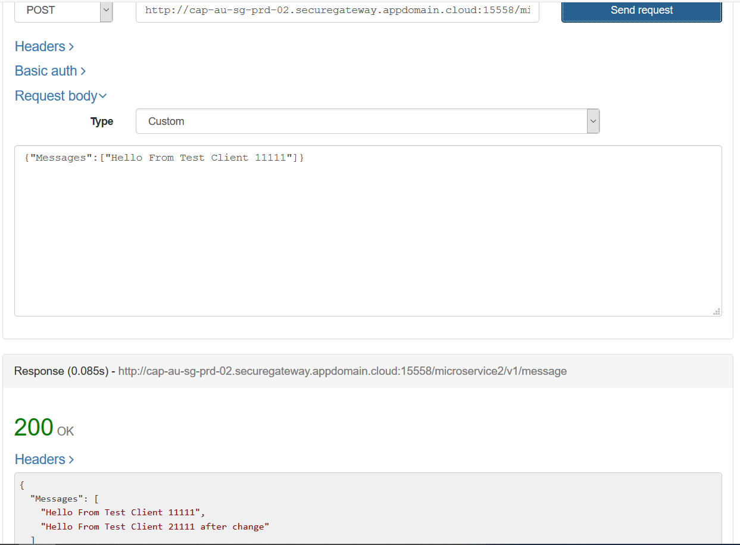

## Calling ACE MS1 via IBM Rational Integration Tester – ACE MS1 calls ACE MS2 stub

For this test ACE MS1 RestRequest node need its URL to call ACE MS2 updated to target the ACE MS2 stub on IBM Rational Integration Tester via the public IP address offered by the IBM Secure Gateway service.

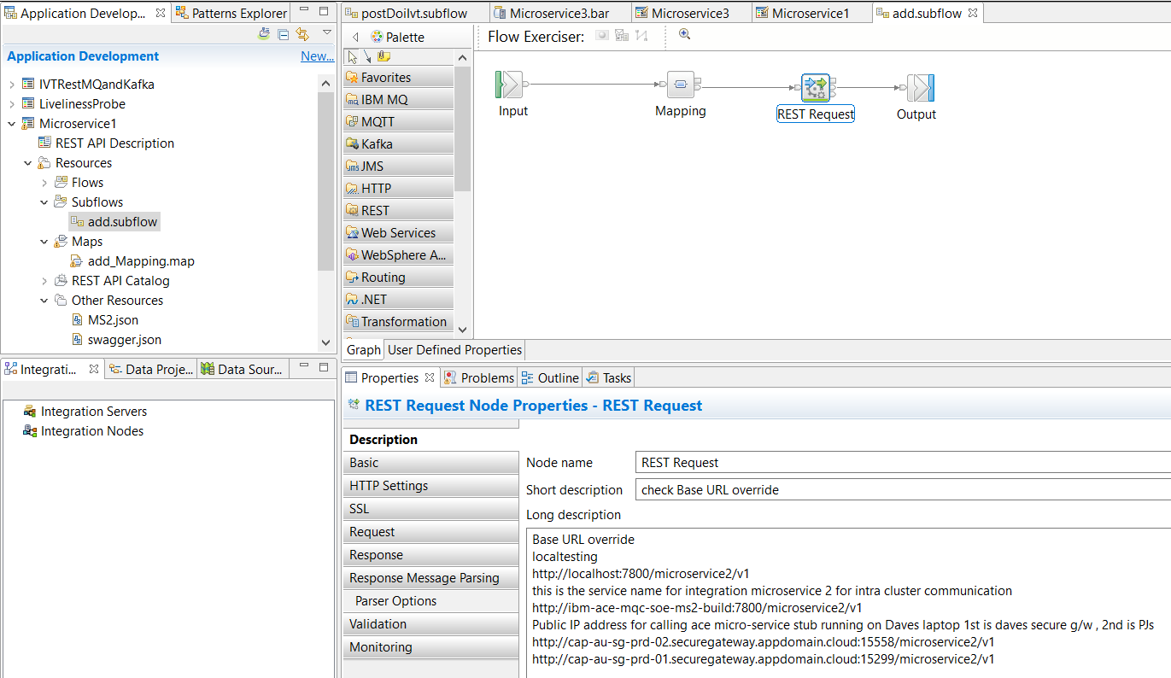

http://cap-au-sg-prd-01.securegateway.appdomain.cloud:15299/microservice2/v1

Rather than changing the source. User the BAR override parms on the BAR file itself

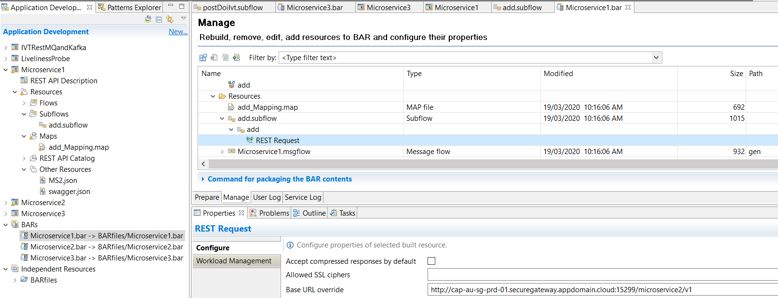

Assuming you have followed document “1.Developer Experience for ACE MQ with RHOS Tools and Tekton v1.1” you will know the next steps are:

1. Save the BAR file
2. Push it to the GIT repos
3. Webhook fires and RHOS will build and deploy a new container with the updated BAR file

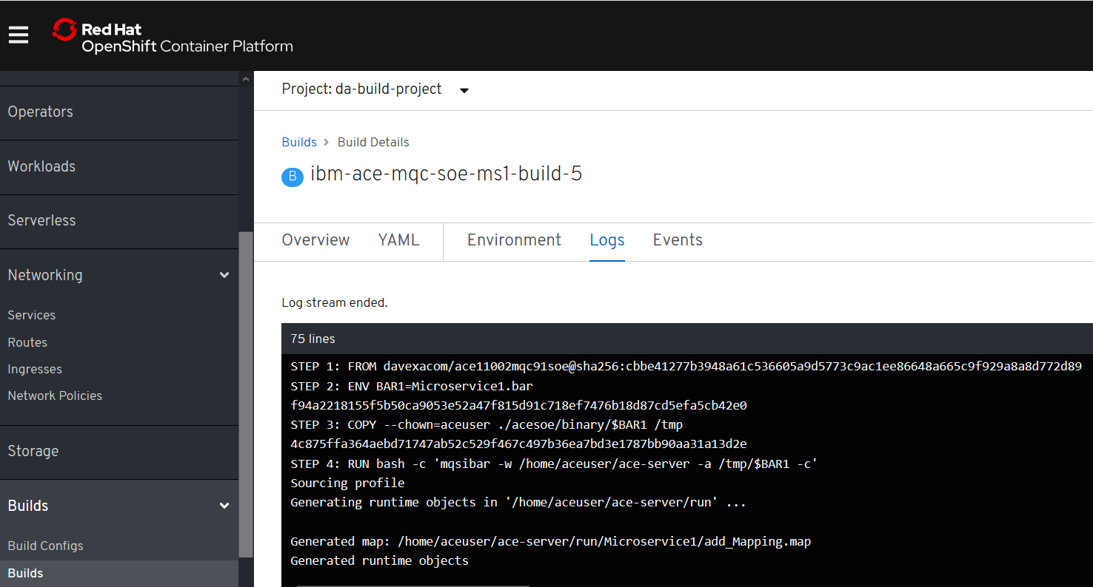

ACE MS1 on RHOS is now pointing (via the secure gateway) to the stub of ACE MS2 on IBM Rational Integration Tester.

### Start the IBM Rational Integration Tester ACE MS2 Stub

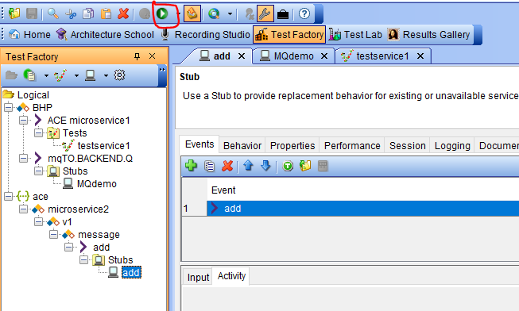

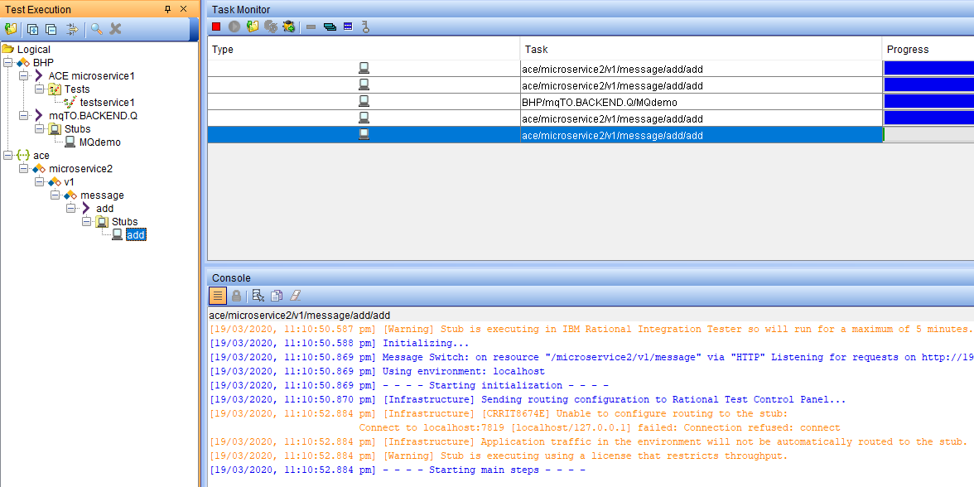

### Invoke ACE MS1 on RHOS from a REST Client

POST

<http://ibm-ace-mqc-soe-ms1-build-da-build-project.apps.cloudpak.ocp4.cloudnativekube.com/microservice1/v1/message>

Data

{"Messages":["Hello From Test Client 111111111111111111"]}

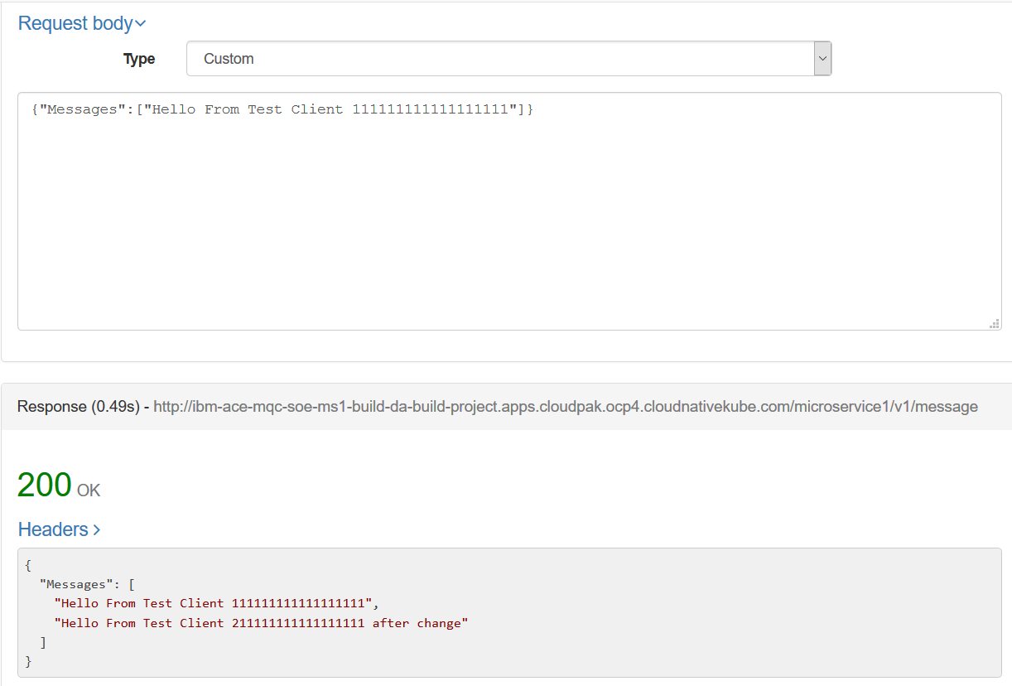

### Observe results in ACE MS 2 stub console

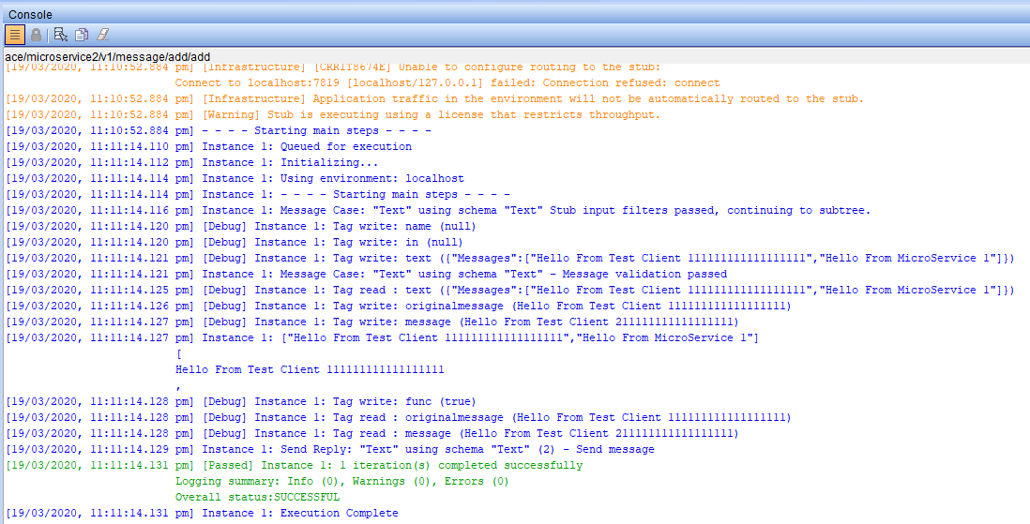

### Invoke ACE MS1 on RHOS from a IBM Rational Integration Tester

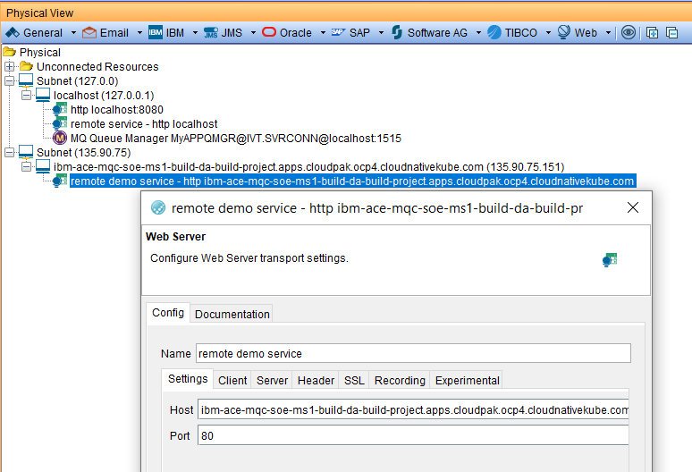

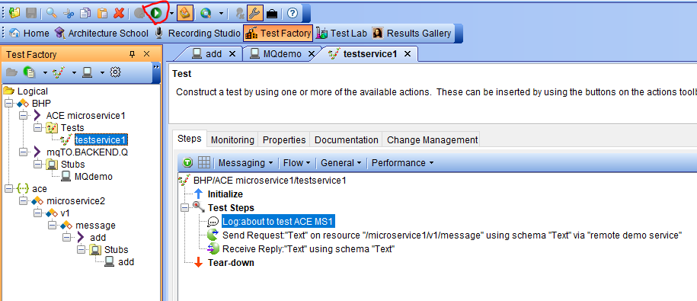

### Observe the results in the stub

### 

### Observer the results in the test

### 

The test actually worked but we have a mismatch between the actual response and the expected response

### 

So our stub is not doing exactly what our actual ACE MS2 is doing

## IBM MQ Queue Manager as backend for ACE MS3

### Queue Manager MyAPPQMGR - configuration

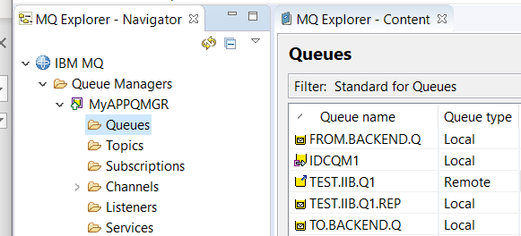

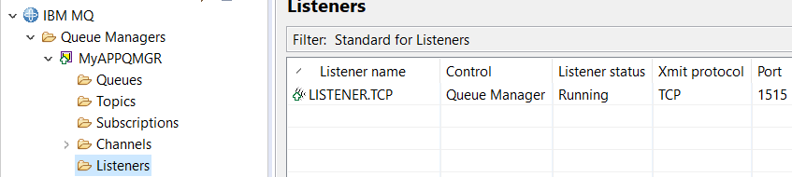

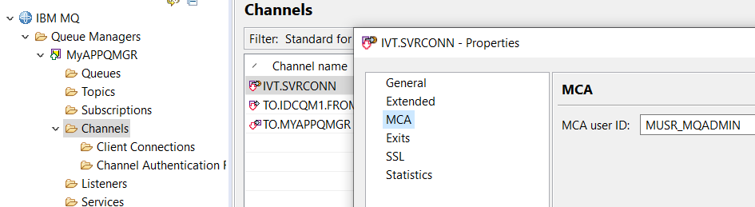

### Channel creation for Linux based queue manager

DEFINE CHANNEL(IVT.SVRCONN) CHLTYPE(SVRCONN) REPLACE

SET CHLAUTH(IVT.SVRCONN) TYPE(BLOCKUSER) USERLIST(nobody)

ALTER AUTHINFO(SYSTEM.DEFAULT.AUTHINFO.IDPWOS) AUTHTYPE(IDPWOS) CHCKCLNT(NONE) ADOPTCTX(YES)

SET CHLAUTH(IVT.SVRCONN) TYPE (ADDRESSMAP) ADDRESS(*) MCAUSER('mqm')

REFRESH SECURITY TYPE(CONNAUTH)

### Channel creation for windows based queue manager

DEFINE CHANNEL(IVT.SVRCONN) CHLTYPE(SVRCONN) REPLACE

SET CHLAUTH(IVT.SVRCONN) TYPE(BLOCKUSER) USERLIST(nobody)

ALTER AUTHINFO(SYSTEM.DEFAULT.AUTHINFO.IDPWOS) AUTHTYPE(IDPWOS) CHCKCLNT(NONE) ADOPTCTX(YES)

SET CHLAUTH(IVT.SVRCONN) TYPE (ADDRESSMAP) ADDRESS(*) MCAUSER('MUSR_MQADMIN')

REFRESH SECURITY TYPE(CONNAUTH)

## IBM Secure Gateway Service – IBM Cloud server side

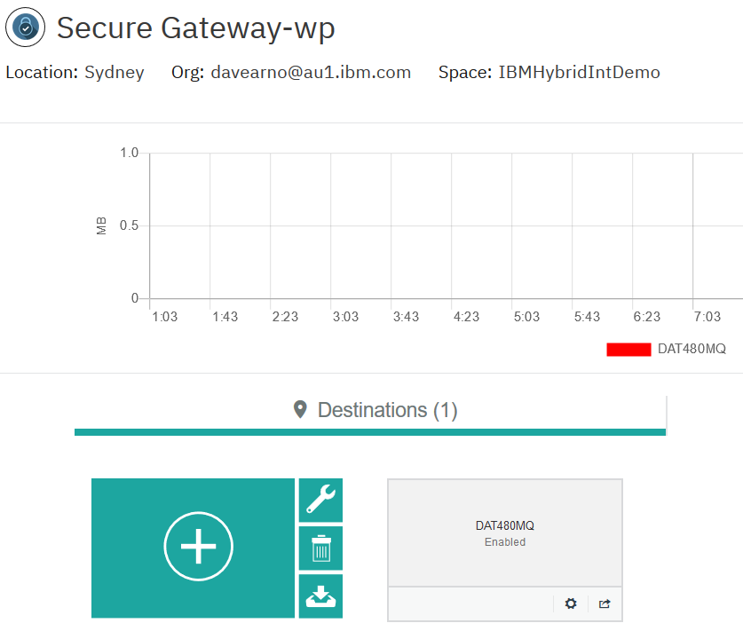

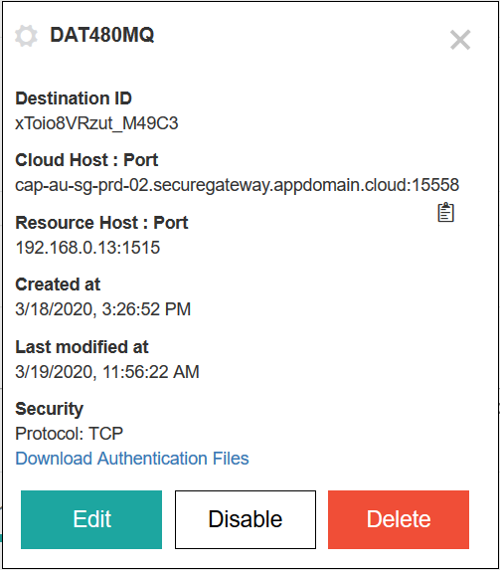

### Parameters matching ACE MS 3 MQOutput configuration

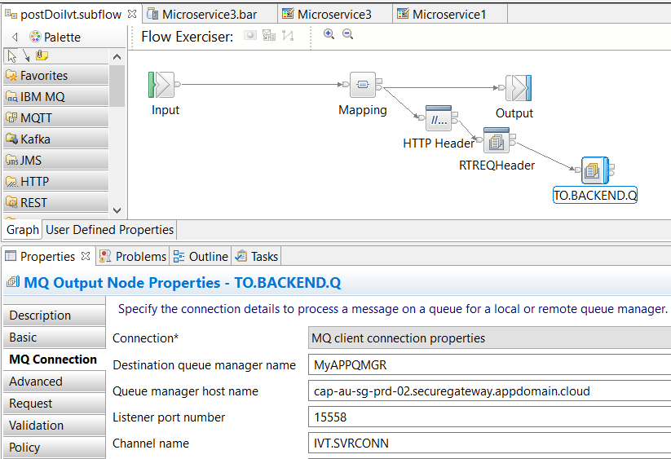

## IBM Secure Gateway Service – Client (Laptop end)

### Windows firewall



### IBm Secure Gateway Service client side

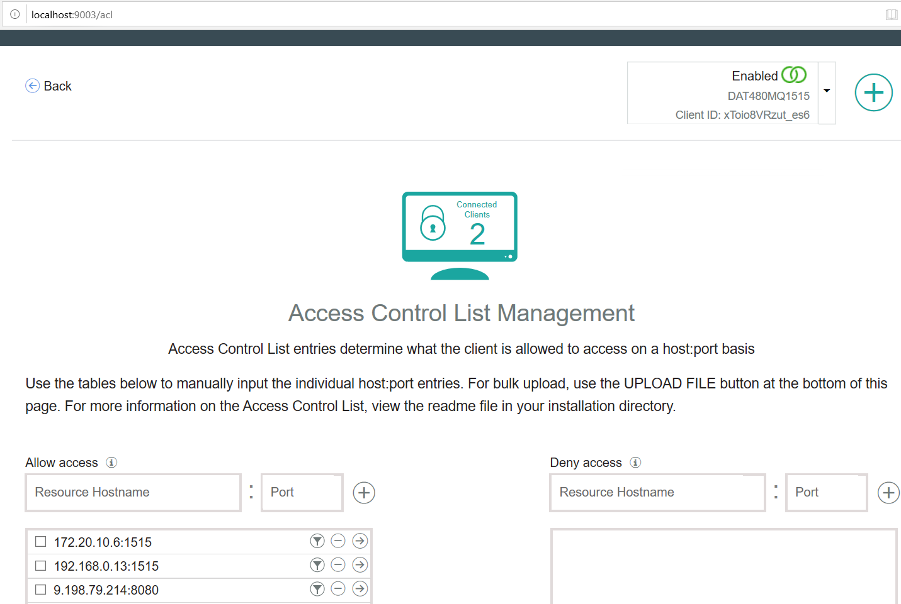

## Testing MQ via IBM Public IP – using RFHUTILC

IVT.SVRCONN/TCP/cap-au-sg-prd-02.securegateway.appdomain.cloud(15558)

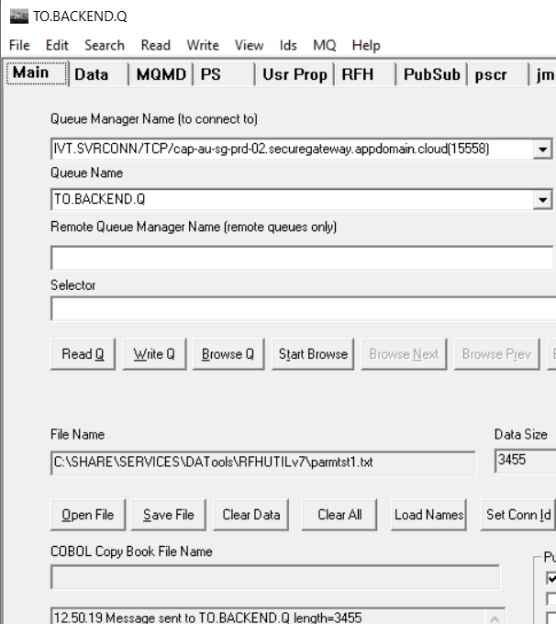

Check the secure gateway client side logs

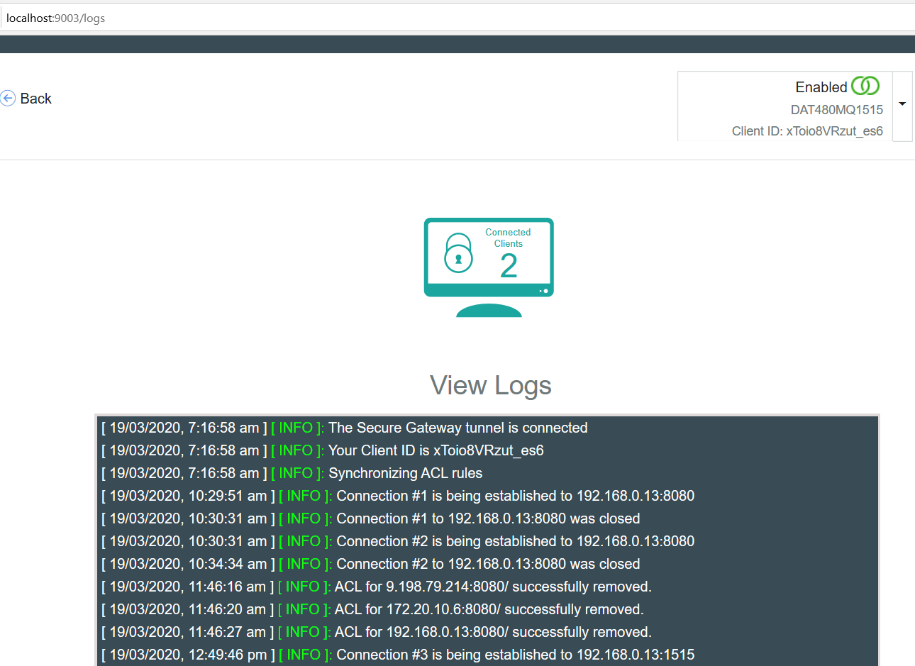

### Check the result on the target queue manager

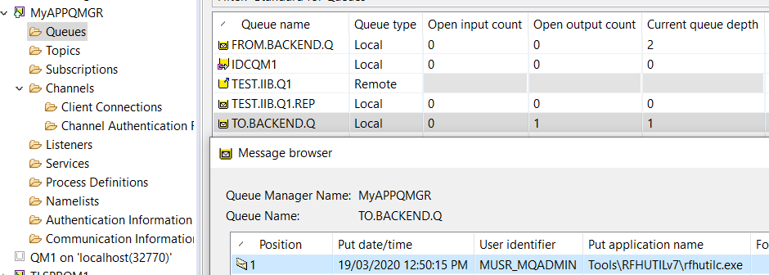

## Testing ACE Microservice 3 to Put to MQ via IBM Public IP

### RHOS Route for ACE MS3

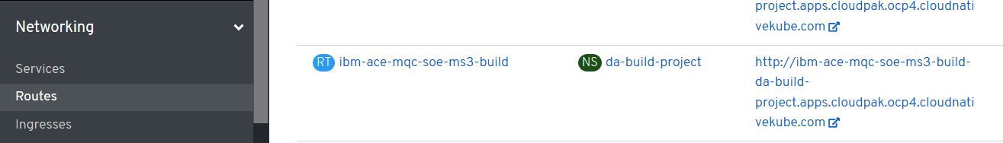

### URL for ACE MS3 service

<http://ibm-ace-mqc-soe-ms3-build-da-build-project.apps.cloudpak.ocp4.cloudnativekube.com/ivtrest/v1/doiIvt>

### Data to test ACE MS3 service

{

"name":"anyname",

"phone":"123545454",

"email": "anyname@host.com"

}

### Test with REST Client

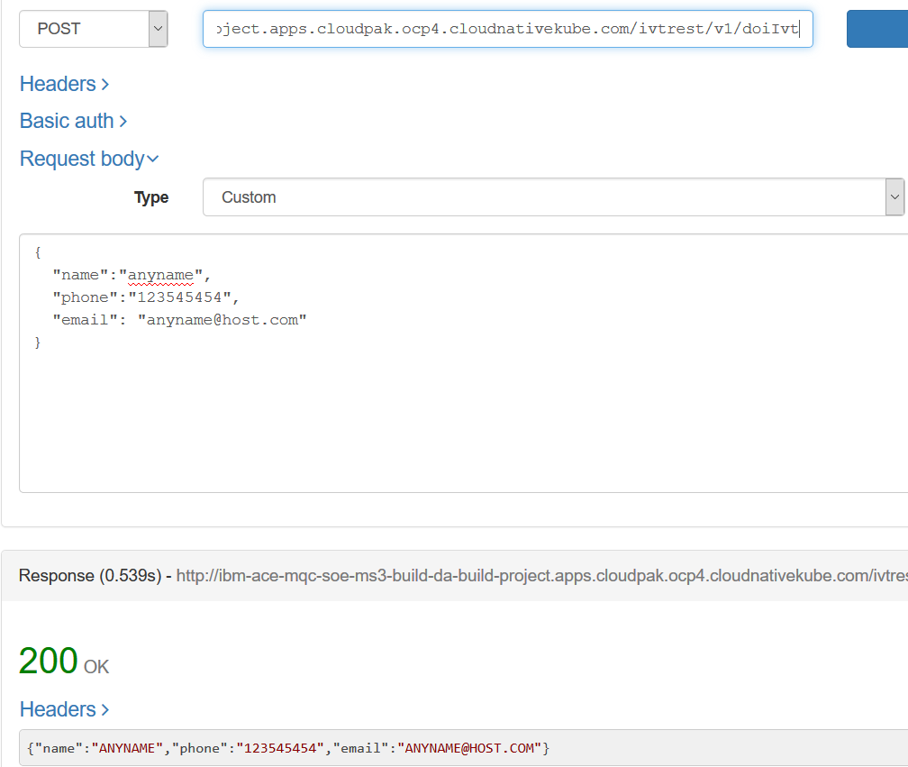

### Check Test Results on MQ

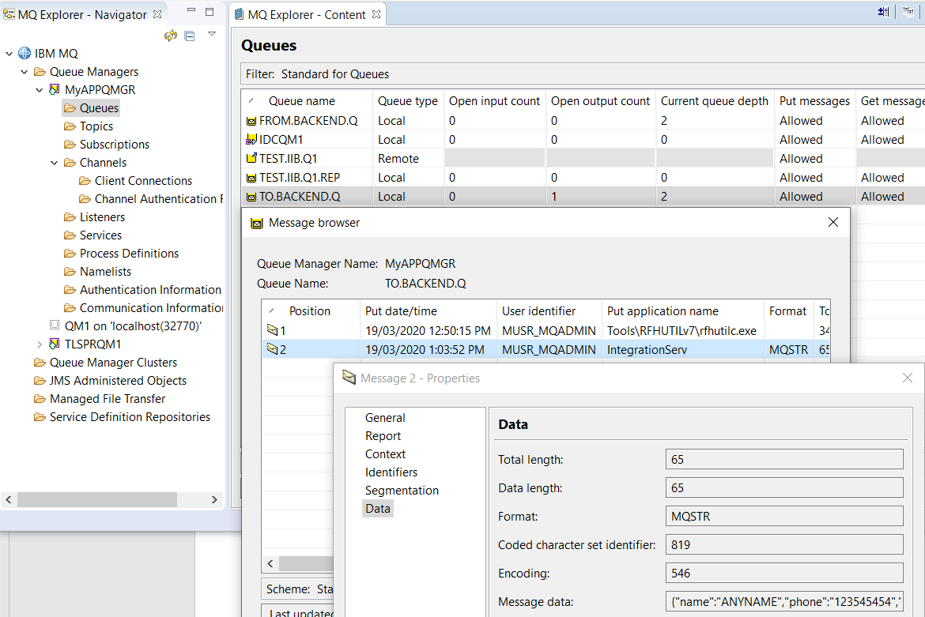

## Using the MQ Stub on IBM Rational Integration Tester as a backend application

### Review stub parameters in IBM Rational Integration Tester

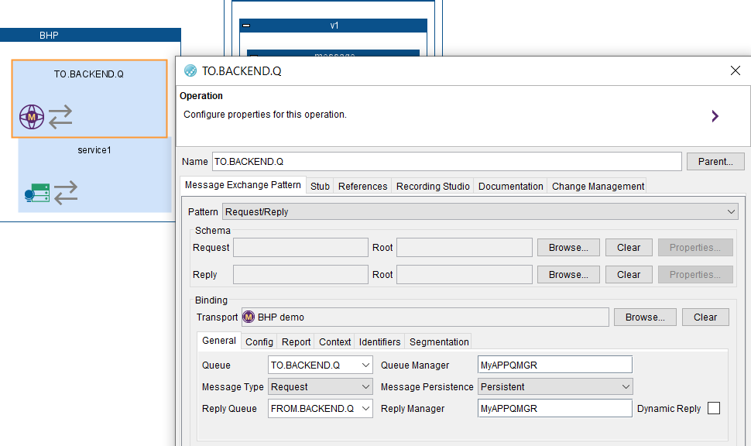

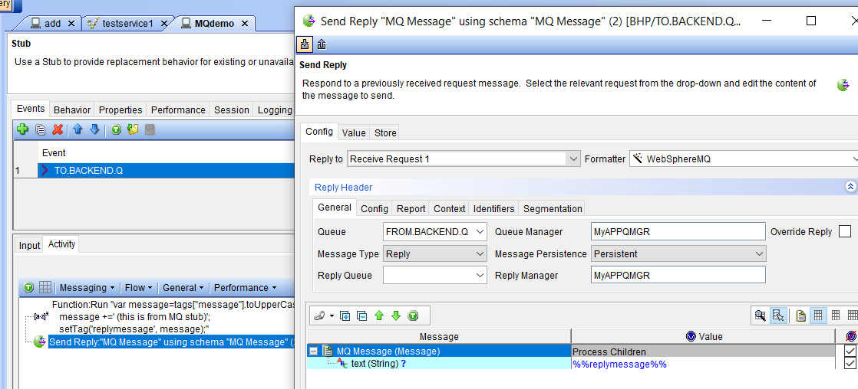

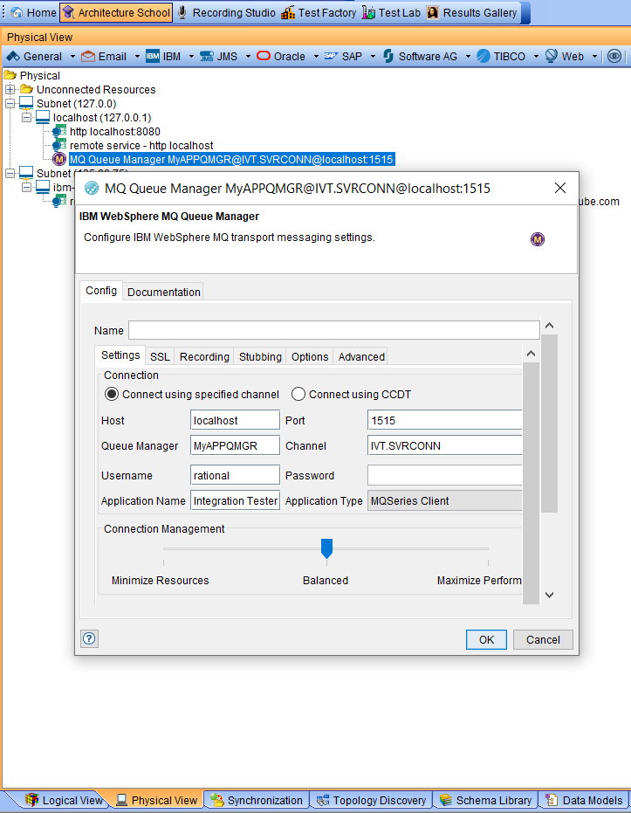

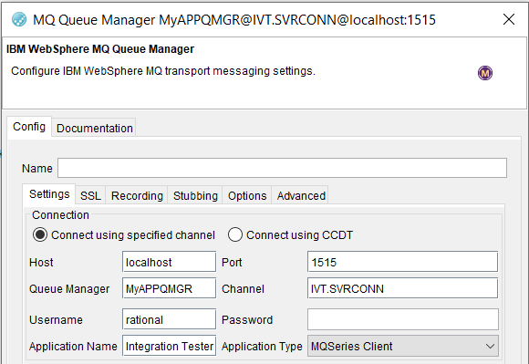

### Stub uses IVT.SVRCONN channel definition in the MyAPPQMGR

DEFINE CHANNEL(IVT.SVRCONN) CHLTYPE(SVRCONN) REPLACE

SET CHLAUTH(IVT.SVRCONN) TYPE(BLOCKUSER) USERLIST(nobody)

ALTER AUTHINFO(SYSTEM.DEFAULT.AUTHINFO.IDPWOS) AUTHTYPE(IDPWOS) CHCKCLNT(NONE) ADOPTCTX(YES)

SET CHLAUTH(IVT.SVRCONN) TYPE (ADDRESSMAP) ADDRESS(*) MCAUSER('')

REFRESH SECURITY TYPE(CONNAUTH)

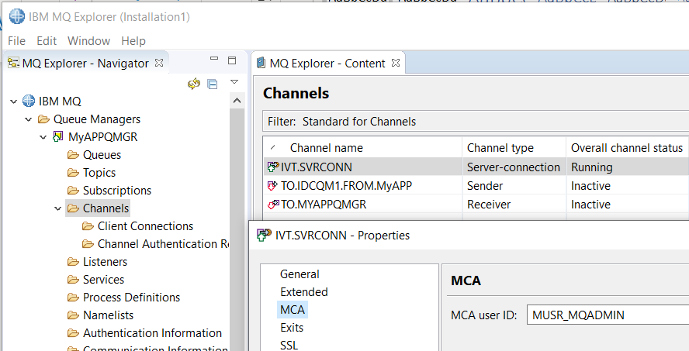

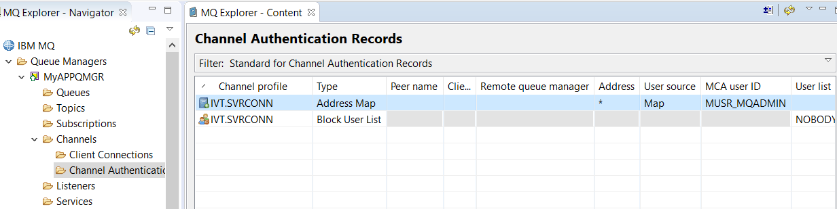

### Start IBM Rational Integration Tester Stub to retrieve messages placed on MQ by ACE MS3

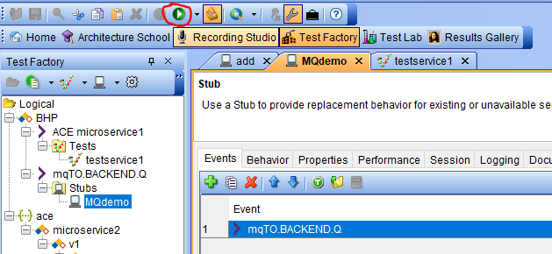

### IBM Rational Integration Tester Stub receives message from ACE MS3

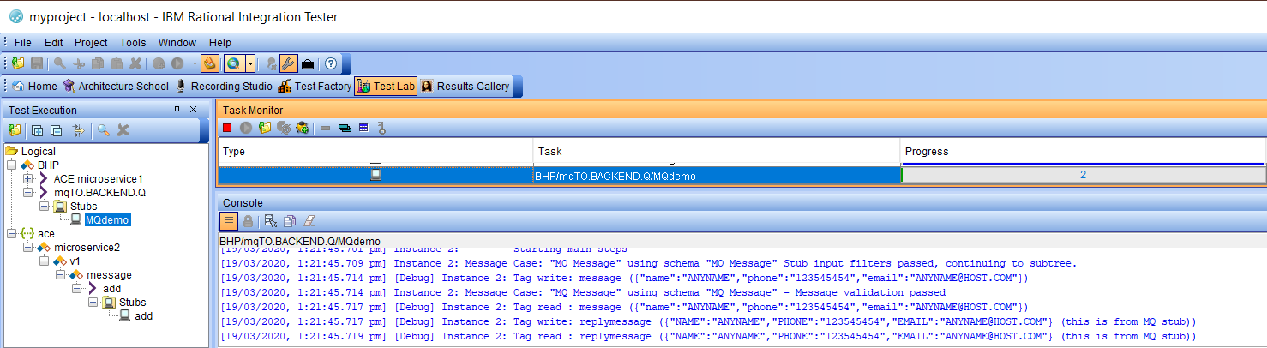

e